**Software**

**Requirements**

**Specification**

**for**

**<Binh Tay Market App>**

**Prepared by <Group_NgocThu>**

**<29/11/2021>**

|  |  |  |
| --- | --- | --- |
| Version | Created Day | By |
| 1.0 | 23/10/2021 | Group_NgocThu |
| 2.0 | 30/10/2021 | Group_NgocThu |
| 3.0 | 07/11/2021 | Group_NgocThu |
| 4.0 | 14/11/2021 | Group_NgocThu |
| 5.0 | 21/11/2021 | Group_NgocThu |
| 6.0 | 29/11/2021 | Group_NgocThu |

Table of Contents

1 Introduction 8

*1.1* Purpose 8

*1.2* Document Conventions 8

*1.3* Intended Audience and Reading Suggestions 8

*1.4* Product Scope 8

*1.5* References 8

2 Overall Description 8

*2.1* Product Functions Requirements 8

2.2 User Classes and Characteristics 9

*2.3* Operating Environment 9

3 External Interface Requirements 10

*3.1* User Interfaces 10

*3.2* Hardware Interfaces 10

4 System Features 10

4.1 Login (Thái Sơn) 10

4.1.1 Overview 10

4.1.2 Actors 10

4.1.3 Use-case diagrams 10

4.1.4 Activity Diagram 11

11

4.1.5 Workflows 11

4.1.6 External interfaces: 12

4.2 Register form (Thái Sơn) 13

4.2.1 Overview 13

4.2.2 Actors 13

4.2.3 Use-case diagrams 13

4.2.4 Activity diagram 14

4.2.5 Workflows 14

4.2.6 External interfaces 16

4.3 Search (Thái Sơn) 17

4.3.1 Overview 17

4.3.2 Actors 17

4.3.3 Use case diagram 17

4.3.4 Activity Diagram 18

4.3.5 Workflows 18

4.3.6 External Interfaces 18

4.4 Update profile (Đức Trí) 20

4.4.1 Overview 20

4.4.2 Actors 20

4.4.3 Use-case diagrams 20

4.4.4 Activity diagram: 21

4.4.5 Workflow 21

4.4.6 External Interfaces 22

4.5 Track order progress (Đức Trí) 23

4.5.1 Overview 23

4.5.2 Actor 23

4.5.3 Use-case diagram 23

4.5.4 Activity diagram: 24

4.5.5 Workflows 24

4.5.6 External interfaces: 25

4.6 Cancel order (Đức Trí) 25

4.6.1 Overview 25

4.6.2 Actors 25

4.6.3 Use-case diagram 26

4.6.4 Activity diagram: 27

4.6.5 Workflows 27

4.6.6 External interfaces 28

4.7 View/ Update Shopping Cart (Duy Thanh) 29

4.7.1 Overview 29

4.7.2 Actors 29

4.7.3 Use-case diagrams 29

4.7.4 Activity diagram 30

4.7.5 Workflows 31

4.7.6 External interfaces 32

4.8 View product details (Duy Thanh) 33

4.8.1 Overview 33

4.8.2 Actors 33

4.8.3 Use-case diagrams 33

4.8.4 Activity diagram 34

4.8.5 Workflows 34

4.8.6 External interfaces 35

4.9 Report saleman’s behaviour (Duy Thanh) 36

4.9.1 Overview 36

4.9.2 Actors 36

4.9.3 Use-case diagrams 36

4.9.4 Activity diagram 37

4.9.5 Workflows 37

4.9.6 External interfaces 39

4.10 Place an order (Ngọc Thư) 40

4.10.1 Overview 40

4.10.2 Actors 40

4.10.3 Use-case diagrams 40

4.10.4 Activity diagram 41

4.10.5 Workflows 42

1.4 Display “Edit Address” screen 42

4.10.6 External interfaces 43

4.11 Try on clothes using 3D scanner (Ngọc Thư) 45

4.11.1 Overview 45

4.11.2 Actors 45

4.11.3 Use-case diagrams 45

4.11.4 Activity diagram 46

46

4.11.5 Workflows 46

4.11.6 External interfaces 46

4.12 Add new product (Ngọc Thư) 48

4.12.1 Overview 48

4.12.2 Actors 48

4.12.3 Use-case diagrams 48

4.12.4 Activity diagram 49

4.12.5 Workflows 49

4.12.6 External interfaces 50

4.13 Confirm order (Ngọc Thư) 52

4.13.1 Overview 52

4.13.2 Actors 52

4.13.3 Use-case diagrams 52

4.13.4 Activity diagram 53

4.13.5 Workflows 53

4.13.6 External interfaces 54

5 Other Nonfunctional Requirements 54

*5.1* Performance Requirements 54

*5.2* Safety Requirements 54

*5.3* Security Requirements 55

*5.4* Software Quality Attributes 55

6 Other Requirements 55

# Introduction

## Purpose

The purpose of this document is to build an online sales system based on AI technology connected to Binh Tay market

## Document Conventions

|  |  |
| --- | --- |
| Term | Definition |
| AI | Artificial Intelligence |
| 3D | Three-dimensional |

## Intended Audience and Reading Suggestions

This is a specification document for Binh Tay Market App, the document is made under the guidance of the lecturer. This document is intended for customers, developers and testers.

## Product Scope

The purpose of this sales system is to allow buyers to easily access and buy products from Binh Tay market with convenient support from AI, sellers can easily post available products at the market for customers who do not go to the market to buy directly.

## References

*IEEE. IEEE Std 830-1998 IEEE Recommended Practice for Software Requirements Specifications. IEEE Computer Society, 1998.*

*Software Requirement Specification with example:*

[*https://krazytech.com/projects/sample-software-requirements-specificationsrs-report-airline-database?fbclid=IwAR3CGxy2LYeVlkXCSN6P9oC849128wGLcQ7NO83Z9-c4byl0U78nW01f3oc*](https://krazytech.com/projects/sample-software-requirements-specificationsrs-report-airline-database?fbclid=IwAR3CGxy2LYeVlkXCSN6P9oC849128wGLcQ7NO83Z9-c4byl0U78nW01f3oc)

*Writing a software requirements specification document:*

[*https://medium.com/@enisinanaj/writing-a-software-requirements-specification-document-97d622805aef*](https://medium.com/@enisinanaj/writing-a-software-requirements-specification-document-97d622805aef)

# Overall Description

## Product Functions Requirements

* Search & filter
* Anti-counterfeiting AI technology
* 3D technology for trying on clothes online
* Locate the address
* Online payment
* AI confirm orders automatically
* Multi-platform support

## User Classes and Characteristics

## Operating Environment

* Android
  + RAM: 2GB or higher
  + Android version 4.0.3 or higher
  + More than 300MB of free memory space
* IOS:
  + Version 8.0 and above
  + Free space of 400MB or more
* Windows

# External Interface Requirements

## User Interfaces

* Front-end software: React Native
* Back-end software: .NET Core
* Database software: MySQL

## Hardware Interfaces

* Windows
* IOS
* Android

# System Features

## Login (Thái Sơn)

### Overview

* This screen is used to login to BinhTayMarketApp

### Actors

* User can login to BinhTayMarketApp

### Use-case diagrams

#### Pre-condition

* User has registered account

#### Post-condition

* User will be able to use BinhTayMarketApp

#### Triggers

* Clicks on the “Login as” button on the login form

### Activity Diagram

*Image 4.1.5.1.1 Login Activity diagram*

### Workflows

|  |  |  |
| --- | --- | --- |
| Scenario | Actor | System |
| 1. User successfully login | 1.1. Go to this login form | 1.2. Display login form |
| 1.3 Enter username, password and click login button or click login with social media account (facebook, google, twitter) | 1.4 Display homepage |
| 2. User inputs invalid data | 2.1 Go to this login form | 2.2 Display login form, keep the contents of the previous fields and remove the contents of fields containing invalid input |
| 2.3 Enter username, password and click login button or click login with social media account (facebook, google, twitter) | 2.4 Dialog error messages of invalid fields will be displayed at the center of screen |

### External interfaces:

#### Prototype:

*Image 4.1.5.1.1 Login Screen*

#### Screen description:

|  |  |  |  |  |  |  |
| --- | --- | --- | --- | --- | --- | --- |
| No | Field name | Control type | Required | Data type | Default value | Description |
| 1 | Username | Textbox | Yes | Text | Blank | Username contains minimum 6 characters, maximum 40 characters |
| 2 | Password | Textbox | Yes | Text | Blank | Password contains minimum 6 characters, maximum 40 characters |
| 3 | Login as customer | Link label | Yes | Text | N/A | Select the login status as a customer |
| 4 | Login as salesman | Label | Yes | Text | N/A | Select the login status as a salesman |
| 5 | Forgot password | Link label | Yes | Text | N/A | Link to change password form |

|  |  |  |  |  |  |  |
| --- | --- | --- | --- | --- | --- | --- |
| Button | | | | | | |
| 1 | Login with Facebook | button | Yes | N/A | N/A | Login with Facebook account |
| 2 | Login with Gmail | Button | Yes | N/A | N/A | Login with Google account |
| 3 | Login with Twitter | Button | Yes | N/A | N/A | Login with Twitter account |
| 4 | Sign up | Button | Yes | N/A | N/A | Register new account |

## Register form (Thái Sơn)

### Overview

* This screen is used to sign up account

### Actors

* Salesman and customer

### Use-case diagrams

#### Pre-condition

* User must open BinhTayMarketApp

#### Post-condition

* User will be able to log in to BinhTayMarketApp

#### Triggers

#### Clicks on the “Sign up” button on the login form

### Activity diagram

*Image 4.2.5.1.1 Register Screen*

### Workflows

|  |  |  |
| --- | --- | --- |
| Scenario | Actor | System |
| 1. User successfully sign up | 1.1. Go to this Register form | 1.2. Display Register form |
| 1.3. Enter all textbox, choose gender in combobox gender, then click “Next” | 1.4 Show “Add ID card” screen |
| 1.5 Add a front of ID photo and behind ID-card photo, then click sign up button | 1.6 Show success message |
| 2. User inputs invalid data | 2.1 Go to this Register form | 2.2. Display Register form |
| 2.3. Enter all textbox, choose gender in combobox gender, then click “Next” | 2.4 Show “Add ID card” screen |
| 2.4 Add a front of ID photo and behind ID-card photo, then click sign up button | 2.4 Dialog error messages of invalid fields will be displayed at the center of screen |

### External interfaces

#### Prototype:

*Image 4.2.5.2.1 Register Screen Image 4.2.5.2.2 Add ID Card Screen(Next)*

#### Screen description:

|  |  |  |  |  |  |  |
| --- | --- | --- | --- | --- | --- | --- |
| No | Field name | Control type | Required | Data type | Default value | Description |
| 1 | Firstname | Textbox | Yes | Text | Blank | Maximum 50 characters |
| 2 | Lastname | Textbox | Yes | Text | Blank | Maximum 50 characters |
| 3 | Phone number | Textbox | Yes | Text | Blank | Integer 0-9  9-11 characters |
| 4 | Email | Textbox | Yes | Text | Blank | Must contain @ |
| 5 | Birthday | Datetime picker | Yes | Date | Date | Format date dd/MM/yyyy |
| 6 | Gender | Combo box | Yes | Text | Male | Select gender |
| Picture box | | | | | | |
| 7 | Front | Picture box | Yes | Image | Blank | Contains the front of the ID card |
| 8 | Behind | Picture box | Yes | Image | Blank | Contains the back of the ID card |
| Button | | | | | | |
| 9 | Next | Button | Yes | N/A | N/A | Click to next step |
| 10 | Sign up | Button | Yes | N/A | N/A | Click to sign up |

## Search (Thái Sơn)

### Overview

* This screen is used to search products

### Actors

* Salesman and customer

### Use case diagram

#### Pre-condition

* User must click search box

#### Post-condition

* Products will display on the screen

#### Triggers

#### Clicks on the “Search” button

### Activity Diagram

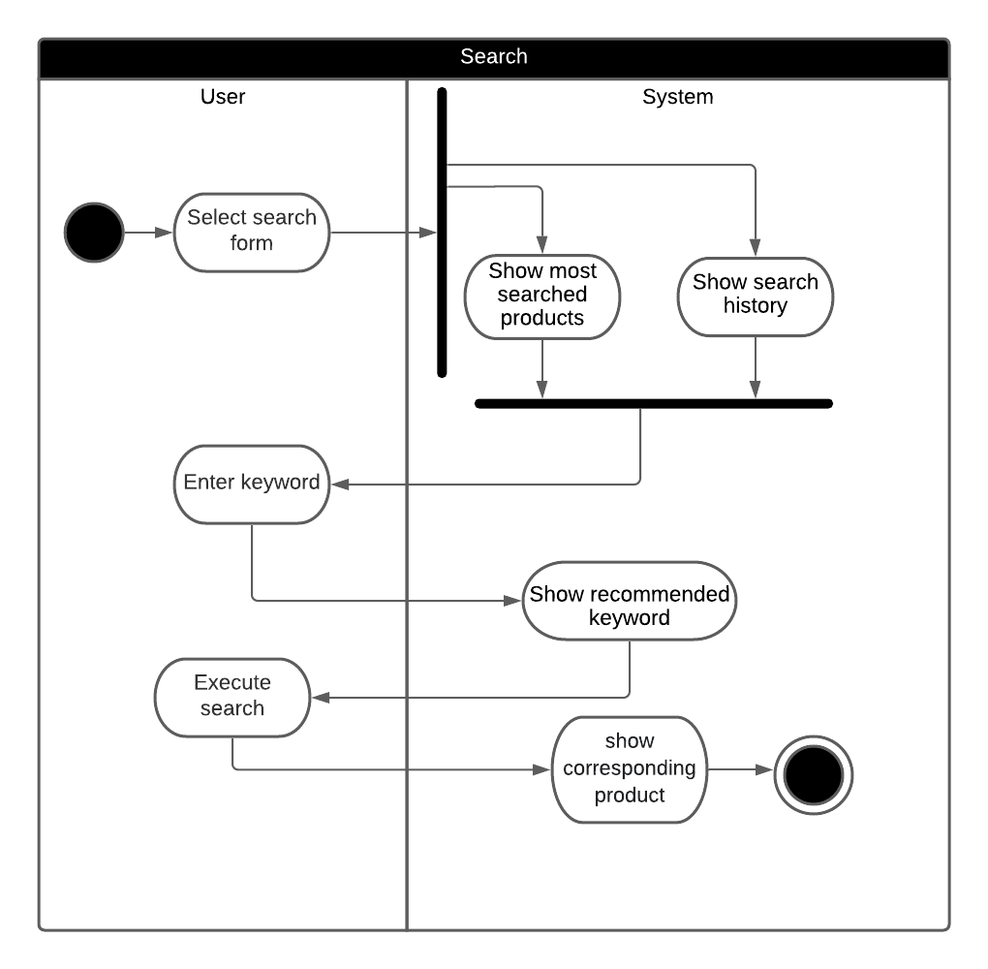

*Image 4.2.5.1.1 Seacrh activity diagram*

### Workflows

|  |  |
| --- | --- |
| Actor | System |
| 1.1. Go to this search form | 1.2. Display search form, search history and recommended keyword |
| 1.3. Enter tagname, categries, product name | 1.4 Show the respective products |

### External Interfaces

#### Protype

*Image 4.2.5.1.1 Seacrh form*

#### Screen description:

|  |  |  |  |  |  |  |
| --- | --- | --- | --- | --- | --- | --- |
| No | Field name | Control type | Required | Data type | Default value | Description |
| 1 | Searchbox | Textbox | Yes | Text | Blank | Search content |
| 2 | Voice recognition | Icon | No | N/A | N/A | Convert speech to text in search input |
| 3 | History | List | No | Text | Text | History search list |
| 4 | Most searched products | List | Yes | Text | Text | Most searched products |
| Button | | | | | | |
| 5 | Search | Button | Yes | N/A | N/A | Click to execute search progress |
| 6 | Cart | Button | Yes | N/A | N/A | Click to show cart |

## Update profile (Đức Trí)

### Overview

* This screen is used to update profile

### Actors

* Salesman and Customer

### Use-case diagrams

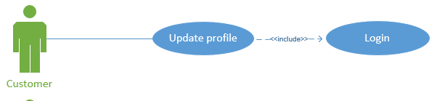

4.3.3.1. Pre-condition

* User click on “Profile” button

4.3.3.2. Post-condition

* Update profile form will be displayed

4.3.3.3. Triggers

* Clicks on the “Done” button on the update profile form

### Activity diagram:

*Image 4.4.4.1 Update profile activity*

### Workflow

|  |  |
| --- | --- |
| Actor | System |
| 1.1. Go to this “Update” form | 1.2. Display “Update profile” screen (4.4.6.1.1) |
| 1.3. Enter all Textbox, choose gender in Combobox gender. Then click Next Button | 1.4 Display “Update ID card” screen( 4.4.6.1.2) |
| 1.5 Add a front of ID photo and behind ID-card photo to corresponding picture box, then click Done button | 1.6 Show success message |

### External Interfaces

#### Prototype:

*Image 4.4.6.1.1 Update profile Image 4.4.6.1.2 Update profile Image*

#### Screen description:

|  |  |  |  |  |  |  |
| --- | --- | --- | --- | --- | --- | --- |
| No | Field name | Control type | Required | Data type | Default value | Description |
| 1 | Firstname | Textbox | Yes | Text | Blank | Maximum 50 characters |
| 2 | Lastname | Textbox | Yes | Text | Blank | Maximum 50 characters |
| 3 | Phone number | Textbox | Yes | Text | Blank | Contains 9-11 characters |
| 4 | Email | Textbox | Yes | Text | Blank | Must contain @ |
| 5 | Birthday | Datetime Picker | Yes | Date | Date | Format date dd/MM/yyyy |
| 6 | Gender | Combo Box | Yes | Text | Male | Select gender |
| Picture box | | | | | | |
| 7 | Front | Picture Box | Yes | Image | Blank | Contains the front of the ID card |
| 8 | Behind | Picture Box | Yes | Image | Blank | Contains the behind of the ID card |
| Button | | | | | | |
| 9 | Next | Button | Yes | N/A | N/A | Next step |
| 10 | Done | Button | Yes | N/A | N/A | Complete update profile |

## Track order progress (Đức Trí)

### Overview

* This screen is used to track order progress

### Actor

Customer

### Use-case diagram

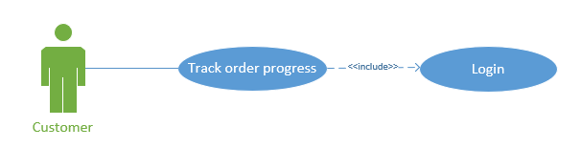

#### Pre-condition

Login Account

#### Post-condition

Customer will able to track order progress

#### Triggers

Customer has placed an order and click in “Wait for confirmation” in Profile

### Activity diagram:

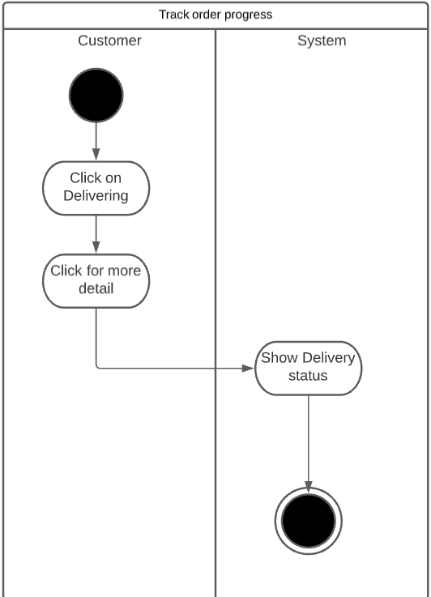

Image 4.5.3.1: Track order progress

### Workflows

|  |  |
| --- | --- |
| Actor | System |
| 1.1. Click on “Delivering” | 1.2. Display “Delivering” screen (4.5.5.1.1) |
| 1.3 Click for more detail | 1.4 Display “Order Progress” screen (4.5.5.1.2) |

### External interfaces:

#### Prototype:

*Image 4.5.5.1.1 Delivering Image 4.5.5.1.2 Oder Progress*

#### Screen description:

|  |  |  |  |  |  |  |
| --- | --- | --- | --- | --- | --- | --- |
| No | Field name | Control type | Required | Data type | Default value | Description |
| 1 | Click for more detail | Link Label | Yes | Text | Blank | Linking to Oder Progress  screen |
| 2 | Google map | N/A | Yes | N/A | Map | Drone’s location |
| 3 | Delivery information | Text Area | Yes | Text | Text | Parcel track |

## 

## Cancel order (Đức Trí)

### Overview

* This screen is used to cancel order

### Actors

* Customer

### Use-case diagram

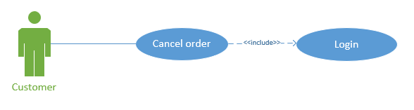

#### Pre-condition

Log in to account

#### Post-condition

Customer will be able to cancel order

#### Triggers

Customer has placed an order and click in “Wait for confirmation” in Profile

### Activity diagram:

4.6.4.1 Cancel Oder

### Workflows

|  |  |
| --- | --- |
| Actor | System |
| 1.1.Go to “Cancel Order” screen | 1.2. Display “Cancel Order” screen (4.6.6.1.1) |
| 1.3. Click Cancel button | 1.4 Show message that customer want to cancel the order or not (4.6.6.1.2) |
| 1.5 Click yes | 1.6 The order will be canceled |
| 1.7 Click no | 1.8 Back to “Cancel Order” screen (4.6.6.1.1) |

### External interfaces

#### Prototype:

*Image 4.6.6.1.1 Cancel Order Screen Image 4.6.6.1.2 Cancel Order Screen*

#### Screen description:

|  |  |  |  |  |  |  |
| --- | --- | --- | --- | --- | --- | --- |
| No | Field name | Control type | Required | Data type | Default value | Description |
| 1 | Product Image | Picture Box | Yes | Text | Blank | Maximum 50 characters |
| 2 | Quantity | Input | Yes | Number | 1 | Integer minimum 1 |
| 3 | Price | Label | Yes | Number | 0 | Integer minimum 0 |

## View/ Update Shopping Cart (Duy Thanh)

### Overview

This screen is used to view/update cart

### Actors

Customer

### Use-case diagrams

#### Pre-condition

User must be logged in

#### Post-condition

Update successfully shopping cart

#### Triggers

#### In the homepage/product details page click on the button

### Activity diagram

*Image 4.7.4 View/ Update Shopping Cart*

### Workflows

|  |  |  |
| --- | --- | --- |
|  | **Actor** | **System** |
| 1. User edit products | 1.1. Click shopping cart icon | 1.2. Display: Show products |
| 1.3 Select items and choose quantity | 1.4 Update items and quantity  Display: items, quantity, delivery cost, total price |
| 2. User click “remove” button | 2.1 Click shopping cart icon | 2.2 Display: Show products |
| 2.3 Click the delete button to the right of the product | 2.4  Case 1: There are no products in the cart   * Display: No items in the cart   Case 2: There are products in the cart   * Display: items, quantity, delivery cost,total price |

### External interfaces

#### Prototype:

*Image 4.7.6.1.1 View/ Update Shopping Cart Image 4.7.6.1.1 View/ Update Shopping Cart*

#### Screen description:

|  |  |  |  |  |  |  |
| --- | --- | --- | --- | --- | --- | --- |
| No | Field name | Control type | Required | Data type | Default value | Description |
| 1 | Empty box | Checkbox | Yes | N/A | Blank | Choose each item |
| 2 | Increase or decrease | Num.Stepper | Yes | Number | 1 | Increase or decrease the amount |
| 3 | Back | Button | Yes | N/A | N/A | Back to product details page/homepage |
| 4 | Purchase | Button | No | N/A | N/A | Pay the bill |
| 5 | Remove | Button | Yes | N/A | N/A | Remove the product from the cart |

## View product details (Duy Thanh)

### Overview

This screen is used view product details

### Actors

Customer

### Use-case diagrams

#### Pre-condition

* Customer click on any product

#### Post-condition

* View product detail

#### Triggers

* In homepage, click on any product

### Activity diagram

*Image 4.8.4 View product details*

### Workflows

|  |  |
| --- | --- |
| **Actor** | **System** |
| 1. Click on any product | 1.2. Display: “product detail” screen. |

### External interfaces

#### Prototype:

*Image 4.8.6.1.1 View product details*

#### Screen description:

|  |  |  |  |  |  |  |
| --- | --- | --- | --- | --- | --- | --- |
| 1. No | Field name | Control type | Required | Data type | Default value | Description |
| 1 | Image | Image | Yes | Image | Blank | Product images |
| 2 | Size | Combobox | Yes | Text | S, M, L, XL | Size |
| 3 | Price | Label | Yes | Number | Blank | Product price |
| 4 | Address | Combobox | Yes | Text | Blank | Receiver's address |
| 5 | Delivery cost | Label | Yes | Number | Blank | Delivery cost |
| 6 | Back | Button | Yes | N/A | N/A | Back to product details page |
| 7 | Bell (icon) | Button | Yes | N/A | N/A | Get notification |
| 8 | Shopping cart (icon) | Button | Yes | N/A | N/A | View Customer’s shopping cart |
| 9 | Try on | Button | Yes | N/A | N/A | Try on clothes |
| 10 | Add to cart | Button | Yes | N/A | N/A | Add item to cart |
| 11 | Buy Now | Button | Yes | N/A | N/A | Go to the payment page |
| 12 | View shop | Button | Yes | N/A | N/A | View shop |

## Report saleman’s behaviour (Duy Thanh)

### Overview

This screen is used to report saleman’s behaviour

### Actors

Customer

### Use-case diagrams

#### Pre-condition

User must be logged in

#### Post-condition

Notification of successful report

#### Triggers

 In the salesman’s page, click the button to report

### Activity diagram

*Image 4.9.4 Report saleman’s behaviour*

### Workflows

|  |  |  |
| --- | --- | --- |
| **Scenario** | **Actor** | **System** |
| 1. User click “yes” | 1.1. Go to “saleman page” and press the button | 1.2. Show notice “Report this user?” |
| 1.3 Click “Yes” | 1.4 Display “Report form” |
| 1.5 Select reason to report | 1.6 Display “Report description” |
| 1.7 Write content and press button “Report” | 1.8 Show notice “Report successfully” |
| 2. User click “no” | 2.1 Go to “saleman page” and press the button | 2.2. Show notice “Report this user?” |
| 2.3 Click “No” | 2.4 Back to interface “salesman page” |

### External interfaces

#### Prototype:

*Image 4.9.5.1.1 Image 4.9.5.1.2*

*Image 4.9.5.1.3 Image 4.9.5.1.4*

#### Screen description:

|  |  |  |  |  |  |  |  |
| --- | --- | --- | --- | --- | --- | --- | --- |
| No | Field name | Control type | Required | Data type | | Default value | Description |
| 1 | Select Reason | Label | Yes | | Text | Blank | Choose a reason to report |
| 2 | Report Description | Textbox | Yes | | Text | Blank | Maximum 50 characters  Detail the content of the report |
| 3 | Back | Button | Yes | | N/A | N/A | Back to saleman’s page |
| 4 | Report | Button | Yes | | N/A | N/A | Send report |

## Place an order (Ngọc Thư)

### Overview

Purchase the products that users have added to the shopping cart

### Actors

Customer, salesman

### Use-case diagrams

#### Pre-condition

Users logged in to the app

Product have been added to the shopping cart

#### Post-condition

Notification of successful order payment

Order detail is presented in “Waiting for confirmation”

#### Triggers

Click on “Purchase” button

### Activity diagram

*Image 4.10.4.1 Place an order activity diagram*

### Workflows

|  |  |  |
| --- | --- | --- |
| **Scenario** | **Actor** | **System** |
| 1. Customer change address | 1.1 Click on “Purchase” button | 1.2 Display “Purchase” screen |
| 1.3 Click on “Change” | 1.4 Display “Edit Address” screen |
| 1.5 Choose city, district, ward.. in the combobox. |  |
| 1.6 Click “Done” | 1.7 Turn back to “Purchase” screen |
| 1.8 Click on “Next” button | 1.9 Display “Payment Method” screen |
| 1.10 Fill in card number, expiration date and CVV. |  |
| 1.11 Click “Done” | 1.12 Validate card, show “Payment complete” |
| 2. Customer doesn’t change address | 2.1 Click on “Purchase” button | 2.2 Display “Purchase” screen |
| 2.3 Click on “Next” button | 2.4 Display “Order Payment” screen |
| 2.5 Fill in card number, expiration date and CVV. |  |
| 2. 6 Click “Done” | 2.7 Validate card, show “Payment complete” |
| 1. Customer   fill in wrong card’s information | 3.1 Click on “Purchase” button | 3.2 Display “Purchase” screen |
| 3.3 Click on “Next” button | 3.4 Display “Order Payment” screen |
| 3.5 Fill in card number, expiration date and CVV. |  |
| 3.6 Click “Done” | 3.7 Show a dialog that customer have typed wrong information |

|  |
| --- |
|  |

### External interfaces

#### Prototype:

*Image 4.10.6.1.1 Purchase screen Image 4.10.6.1.2 Edit address screen*

*Image 4.10.6.1.3 Payment method screen*

#### Screen description:

|  |  |  |  |  |  |  |
| --- | --- | --- | --- | --- | --- | --- |
| No | Field name | Control type | Required | Data type | Default value | Description |
| 1 | Your address | Label | Yes | N/A | N/A | Display delivery address |
| 2 | Change | Link label | Yes | N/A | N/A | Click to change address |
| 3 | Total | Label | Yes | Double | 0 | Total price of all product |
| 4 | Delivery cost | Label | Yes | Double | 0 | Delivery cost |
| 5 | Total payment | Label | Yes | Double | 0 | Sum of total price and delivery cost |
| 6 | City | Combobox | Yes | Text | List of 63 city/province | Define city name |
| 7 | District | Combobox | Yes | Text | List district of the above selected city | Indicate address’s district |
| 8 | Street | Textbox | Yes | Text | Blank | Specify the street |
| 9 | Done | Button | Yes | N/A | N/A |  |
| 11 | Card number | Textbox | Yes | Text | Blank | Number in the front of the card |
| 12 | Expiration date | Textbox | Yes | Text | N/A | Expiration date of the card |
| 13 | CVV | Textbox | Yes | Number | Blank | Card Verification Value |
| 14 | Next | Button | Yes | N/A | N/A | Button for completing order |

## Try on clothes using 3D scanner (Ngọc Thư)

### Overview

Virtual try-on is used to help the customer easily to figure out his/her image when wearing this cloth.

### Actors

Customer, salesman

### Use-case diagrams

#### Pre-condition

Choose to see detail of cloth product

#### Post-condition

Display 3D body image

#### Triggers

In “Product cloth detail” screen , user click “Try on” button

### Activity diagram

*Image 4.11.5.1.1 Try on clothes using 3D scanner activity diagram*

### Workflows

|  |  |
| --- | --- |
| **Actor** | **System** |
| 1.1. Go to “Cloth detail” screen | 1.2. Display “Cloth detail” screen. |
| 1.3 Click on “Try on” button | 1.4 Display 3D model |
| 1.5 Click back arrow | 1.6 Turn back to product detail page |

### External interfaces

#### Prototype:

*Image 4.11.5.2.1 Product detail screen*

#### Description

|  |  |  |  |  |  |  |
| --- | --- | --- | --- | --- | --- | --- |
| No | Field name | Control type | Required | Data type | Default value | Description |
| 1 | Price | Label | Yes | Double | 0 | Price of product |
| 2 | Size | Combobox | Yes | Text | S, M, L, XL | Size of cloth |
| 3 | Address | Combobox | Yes | Text | Current location | Address of customer |
| 4 | Delivery cost | Label | Yes | Double | 0 | Delivery cost of the selected address |
| 6 | Try on | Button | Yes | N/A | N/A | Button for display try on image |
| 7 | Add to cart | Button | Yes | N/A | N/A | Add this product to cart |
| 8 | Buy now | Button | Yes | N/A | N/A | Quickly order this product without going to cart |
| 9 | View shop | Button | Yes | N/A | N/A | Click to see this shop |

## Add new product (Ngọc Thư)

### Overview

Salesman is able to add new product for his/her shop

### Actors

Salesman

### Use-case diagrams

#### Pre-condition

A Salesman has registered an account for business purpose

Salesman clicked on view “My shop”

#### Post-condition

Products are added to the shop

#### Triggers

Click on “Add new products” label

### Activity diagram

*Image 4.12.5.1.1 Add new product activity diagram*

### Workflows

|  |  |  |
| --- | --- | --- |
| **Scenario** | **Actor** | **System** |
| 1.User successfully add new product | 1.1. Go to “Add new products” screen | 1.2. Display “Add new products” screen. |
| 1.3 Fill all information about this product |  |
| 1.4 Salesman attach image and QR code by clicking icon |  |
| 1.5 Click on “Add” button | 1.6 Validate the barcode and image. Show success message. Add product to “My product” catalog and save to database |
| 2. User inputs invalid QR code/ image | 1.1. Go to “Add new products” screen | 1.2. Display “Add new products” screen. |
| 1.3 Fill all information about this product |  |
| 1.4 Salesman attach image and QR code by clicking icon |  |
| 1.5 Click on “Add” button | 1.6 Show message product is uncertified product or QR code/image is invalid |

### External interfaces

#### Protype

*Image 4.12.5.2.1 Add new product screen*

#### Description

|  |  |  |  |  |  |  |
| --- | --- | --- | --- | --- | --- | --- |
| No | Field name | Control type | Required | Data type | Default value | Description |
| 1 | Price | Label | Yes | Double | N/A | Price of product |
| 2 | Size | Combobox | Yes | Text | S, M, L, XL | Size of cloth |
| 3 | Description | Text area | Yes | Text | Blank | Description of this product |
| 4 | Image | Picturebox | Yes | N/A | N/A | Image of this product |
| 5 | Barcode | Barcode scanner | Yes | N/A | N/A | Barcode of this product |
| 6 | Add | Button | Yes | N/A | N/A | Add new product |

## Confirm order (Ngọc Thư)

### Overview

If an order has been placed, it will be shown in “Waiting for confirmation”. Salesman can confirm that order before preparing and deliver for drone

### Actors

Salesman

### Use-case diagrams

#### Pre-condition

Salesman has registered account for business purpose

Order has been placed by customer

Salesman click on view “My shop”

#### Post-condition

Confirmed orderss will be removed from this catalog and move to “Confirmed order”

#### Triggers

Click on “Wait for confirmation” label

### Activity diagram

*Image 4.13.5.1.1 Confirm order activity diagram*

### Workflows

|  |  |
| --- | --- |
| **Actor** | **System** |
| 1.1. Go to “Wait for confirmation” screen | 1.2. Display “Wait for confirmation” screen. |
| 1.3 “Confirm” button | 1.4. Add this order into “Comfirmed order”, dispose this order |
| 1.5 Click on turn back arrow | 1.6 Back to “My shop” screen |

### External interfaces

#### Protype

*Image 4.13.5.2.1 Wait for confirmation screen*

#### Description

|  |  |  |  |  |  |  |
| --- | --- | --- | --- | --- | --- | --- |
| No | Field name | Control type | Required | Data type | Default value | Description |
| 1 | Customer .. | Link label | No | Text | N/A | Customer’s username/name |
| 2 | Confirm | Button | No | N/A | N/A | Confirm order |

# Other Nonfunctional Requirements

## Performance Requirements

* The application loads to the homepage within 3 seconds
* The application responds to the user's actions within 2 seconds

## Safety Requirements

* Database does not lose data
* Regular backups
* Encrypted customer information
* Do not show customer password unless customer clicks show password
* Only display the last 4 digits of the customer's bank card account

## Security Requirements

* Two-factor authentication
* Send notification of customer's phone number/email when another device logs in to the account
* The app automatically asks for the password when the customer opens the app after 5 minutes of inactivity
* Login with password, fingerprint, face recognition
* The system always uses Secure Sockets Layer (SSL) in all transactions containing sensitive customer information.

## Software Quality Attributes

* Availability: available goods are sufficient to meet customer needs
* Correctness: accurate display and transmission information: which seller's order information is only transmitted to that seller, the drone recognizes the face correctly before delivering to the customer
* Usability: users can easily use the system without any further complicated instructions

# Other Requirements